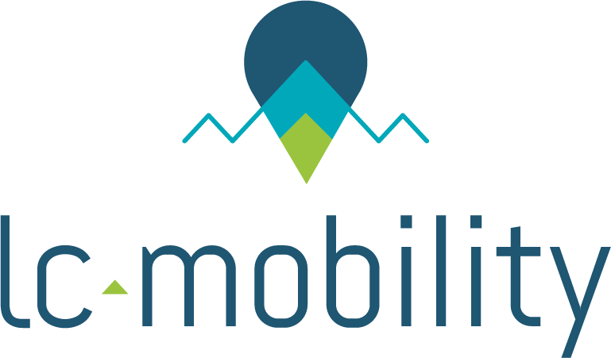

Packs presentation

The services we offer to International comers are divided in several packs. The services are adapted considering the duration of the stay, and are organised to meet all new comers needs, whatever their nationality, age, professional and personal situation.

The list of services for each pack is detailed in page 2.

Six basic packs are offered to you:
- Pack 1 (Very Short Stay) : 1 to 3 months
- Pack 2 (Short Stay) : 3 to 6 months
- Pack 3 (Long Stay) – Individual : more than 6 months
- Pack 4 (Long Stay) – Couple : more than 6 months (on site visits included)
- Pack 5 (Long Stay) – Family : more than 6 months (on site visits included)
- Pack 6 (Administrative Services Except Accommodation) : all duration

Five further optional services are offered:

- Option 1 : assistance for departure (at the end of the stay)
- Option 2 : support to social security
- Option 3 : support to resident permit procedure
- Option 4 : arrival after 8:00PM (hotel night at the arrival included)
- Option 5 : on site visits for an “Individual – Long Stay”
- Option 6 : temporary accommodation (3 proposals + booking)
- Option 7 : Half-day visit of the city

Included services in pack :

Packs | Included services in packs | Price Without Taxe
Pack 1: Very Short Stay  (from 1 to 3 months) | Accommodation booking before the arrival  All included residences only | 280 €
 | Solution to replace french guarantor
 | Lease signature / Inventory support
 | Information on how to reach Grenoble
 | Welcome at the station
 | Welcome book
 | Insurances
Pack 2: Short Stay  (from 3 to 6 months) | Accommodation booking before the arrival  All-included and student residence only | 530 €
 | Solution to replace french guarantor
 | Lease signature / Inventory support
 | Information on how to reach Grenoble
 | Welcome at the station
 | Welcome book
 | Apply for housing assistance (CAF file)
 | Opening accounts: bank/ Water-Gas-Electricity
 | Transportation card subscription
 | Mobile phone / Internet support
 | Insurances
 | Information on french courses
Pack 3: Individual Long Stay  (more than 6 months) | Accommodation booking before the arrival | 750 €
 | Solution to replace french guarantor
 | Lease signature / Inventory support
 | Information on how to reach Grenoble
 | Welcome at the station
 | Welcome book
 | Apply for housing assistance (CAF file)
 | Opening accounts: bank / Water-Gas-Electricity
 | Transportation card subscription
 | Mobile phone / Internet support
 | Insurances
 | Personal assistance of 2 hours
 | Information on french courses

Packs | Included services in packs | Price Without Taxe
Pack 4: Couple Long Stay (more than 6 months) | On site visits + temporary accommodation booking | 1100 €
 | Solution to replace french guarantor
 | Lease signature / Inventory support
 | Information on how to reach Grenoble
 | Welcome at the station
 | Welcome book
 | Apply for housing assistance (CAF file)
 | Opening accounts: bank / Water-Gas-Electricity
 | Transportation card subscription
 | Mobile phone / Internet support
 | Insurances
 | Personal assistance of 2 hours
 | Information on french courses
 | Adjustment for all procedures to the partner
Pack 5: Family Long Stay (more than 6 months) | On site visits + temporary accommodation booking | 1350 €
 | Solution to replace french guarantor
 | Lease signature / Inventory support
 | Information on how to reach Grenoble
 | Welcome at the station
 | Welcome book
 | Apply for housing assistance (CAF file)
 | Opening accounts: bank / Water-Gas-Electricity
 | Transportation card subscription
 | Mobile phone / Internet support
 | Insurances
 | Personal assistance of 2 hours
 | Information on french courses
 | Adjustment for all procedures to the partner and children
 | School enrolment
Pack 6: Services  (except accommodation) | Information on how to reach Grenoble | 320 €
 | Welcome book
 | Apply for housing assistance (CAF file)
 | Opening accounts: bank / Water-Gas-Electricity
 | Transportation card subscription
 | Personal assistance of 2 hours
 | Information on french courses
 | School enrolment

=

Optional additional services | Price Without Taxe
Assistance for departure (at the end of the stay) | 200 €
Assistance for social security | 100 €
Support to resident permit procedure | 100 €
Arrival after 8:00PM (hotel night at the arrival included) | 100 €
On site visits for an “Individual – Long Stay” | 200 €
Temporary accommodation (3 proposals + booking) | 50€
Half-day visit of the city | 400€

For further details, you can contact us by phone at 04.76.50.25.83 / 07.60.06.23.19 or by email
contact@lc-mobility.com

